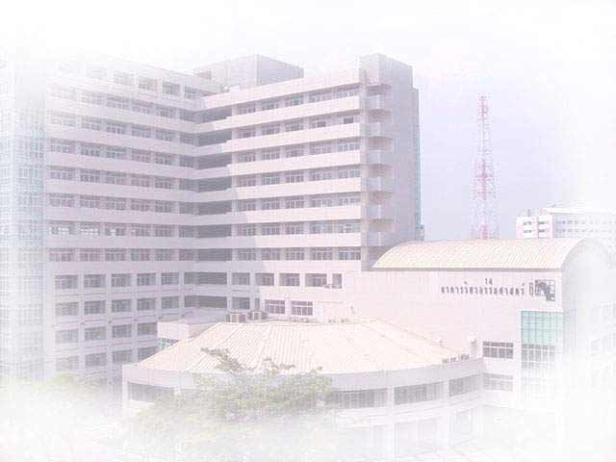
International Graduate Program in Civil Engineering
( IPCE )
Department of Civil Engineering, Faculty of Engineering, Kasetsart University
Major:

1. Structural Engineering (ST)
2. Construction Engineering and Management (CM)

Second Semester 2008 Admission

- Academic Program 2 years (4 semesters)
- Academic Staff Kasetsart University
Tokyo Institute of Technology, Japan
Kumamoto University, Japan
Griffith University, Australia
- Class Schedule Monday – Friday 6.00 p.m. – 9.00 p.m.
Saturday 9.00 a.m. – 4.00 p.m.
- Qualifications Bachelor Degree in Civil Engineering
or related field
- Expenditure About 65,000 baht per semester or 260,000 Baht
(6,500 U.S. dollars) per program
- Application Form Available at the web site and office all year round

- Application Now – October 17, 2008

- Start of Semester October 27, 2008

- Location Room 8505, Building 8, Faculty of Engineering,
Kasetsart University
- Inquiry Tel. 02-942-8555 ext. 1333
Tel./Fax. 02-579-3171
civilinter@ku.ac.th
- Website http://civilinter.eng.ku.ac.th

International Graduate Program in Civil Engineering
( IPCE )
Department of Civil Engineering, Faculty of Engineering, Kasetsart University

SECOND SEMESTER 2008

ADMISSION CALENDAR

SCHEDULES | DATE
- Application Form Download  http://civilinter.eng.ku.ac.th | Now –October 17, 2008
- Submission of Application Form | Now – October 17, 2008
 | Mon – Fri  Sat | - 09.00 AM.–07.00 PM.  - 09.00 AM.–12.00 NOON
- Interview (English) | October 18, 2008 | - 10.00AM.–12.00 NOON
- Announcement of Successful Applicants | October 22, 2008
- Report and Receive Documents  for Registration | October 27, 2008
- Orientation for New Students | October 27, 2008
- Start of Semester | October 27, 2008
- English Examination | September 14 , 2008 or December 14, 2008

Contact No: Tel. / Fax. 02-5793171

